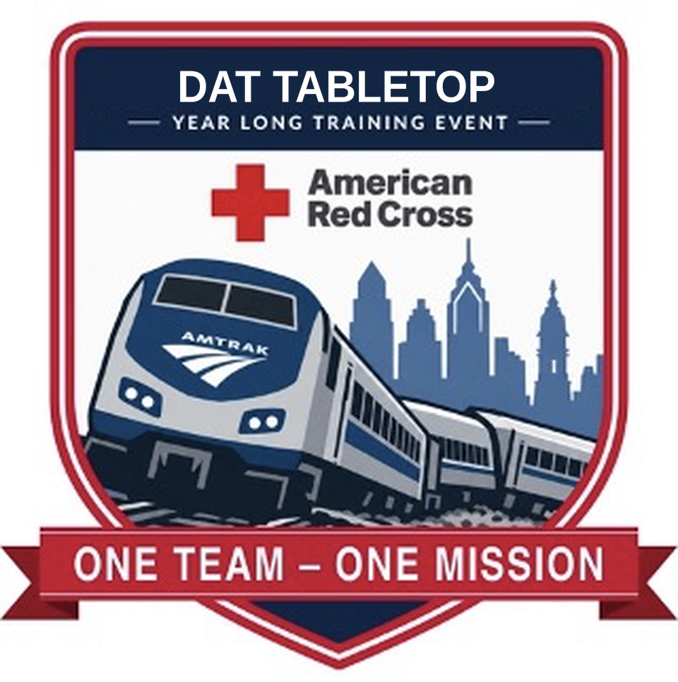
This year, all teams within DCS are building their tabletops and roleplay exercises around different elements of a single large-scale event. In May, it all comes together in a huge, division-wide live action simulation of an Amtrak derailment here in Philadelphia. With every team working to solve the same broader problem all year, we can find opportunities to improve alignment and be better poised to rapidly fulfill our mission should the worst ever arise.
What this means for the DAT team
October 27 Tabletop  Hours 1 and 2 of the event  Information is spotty and we are the first responders dispatched to the scene. | Spring Roleplay  Hours 3 and 4 of the event  Our role pivots to data collection, communication, coordination and reception center client care. | May Live Simulation  All of DCS  A division-wide, live action Amtrak derailment exercise here in Philadelphia.

For field responders and duty officers
Duty officers are absolutely essential to effective communication and inter-team coordination, and this tabletop is a great chance for all of us to better understand each other's roles. Join us to begin this journey and see how our DAT roles evolve as events transpire.
Tuesday, October 27 · 6 to 9 PM  Spring Garden Street, Philadelphia | Register here  [REGISTRATION LINK]

